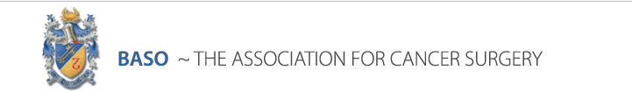
Surgical Oncology in the Emergency Setting
Liverpool University Hospital
08:00-08:25 | Registration and coffee.
08:25-08:30 | Welcome and introduction |  | Rafael Diaz-Nieto
08:30-09:00 | Oncological challenges in Emmergency Surgery – Overview - |  | Mr. Nikhil Misra
09:00-09:30 | Colonic Cancer |  | Mr. Richard Guy
-bleeding vs obstruction- ?diverticulitis
-need for staging-
-malignant obstruction-
-treatment options-
09:30-10:00 | Rectal Cancer |  | Mr. Paul Skaife
-stent vs diversion-
-perineal abscess/fistulation-
10:00-10:30 | Appendiceal Cancer |  | Mr. James Arthur
-incidental finding-
-intraoperative finding-
10:30-11:00 | Peritoneal Carcinomatosis |  | Mr. Chelliah Selvasekar
-presentation-
-staging-
-management-
11:00-11:30 | Coffee break
11:30-12:00 | Pancreatic Cancer |  | Mr. Kulbir Mann
-presentation- ?pancreatitis
-diagnosis-
-management-
12:00-12:30 | Obstructive Jaundice |  | Dr. Nick Stern
 |  | -general management-
12:30-13:00 | Gallbladder Cancer |  | Mr. Robert Jones
-incidental finding-
-presentation- ?liver abscess
13:00-13:30 | Liver malignancies |  | Mr. Steve Fenwick
-Bleeding HCC-
-Presentation- ?liver abscess
13:30-14:30 | Lunch break
14:30-15:00 | OG Cancer |  | Mr. Ajay Sud
-presentation-
-management-
15:00-15:30 | Thoracic malignancies |  | Mr. Mike Shackcloth
-presentation-
-management-
15:30-16:00 | Breast Cancer |  | Mr. Lee Martin
-presentation- ?abscess
-management-
16:00-16:30 | Acute Oncology |  | Dr. Alia Alchawaf
16:30-17:00 | Closure |  | Rafael Diaz-Nieto

