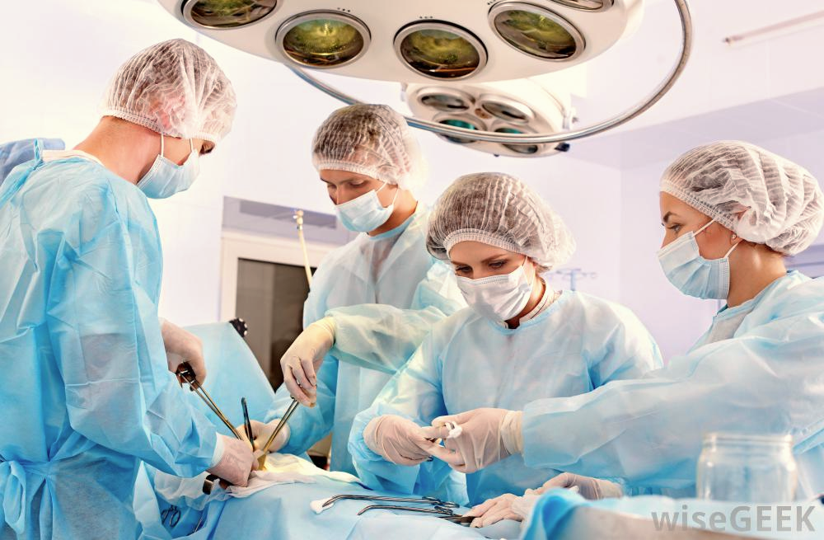

This course is endorsed by **BASO ~ The Association for Cancer Surgery**

Attend the course and become a BASO member

**Coordinators:** Mr M.Kuzman (Surgical SpR), Dr R. Ranat (FY1), Mr S. Al Zubaidy (Surgical SpR),

Mr M. Hanna (Surgical SHO), Mr D. Karavias (Clinical Fellow).

**Supervising Consultant:** Mr D. Gomez (Consultant HPB and General Surgeon)

The aim of the course is improve your knowledge and ability to confidently manage **common general surgical presentations** that you are likely to encounter as a foundation year doctor. The day will include **short tutorials** as well as **registrar-led workshops.**

Learn and improve **key practical skills** needed for surgery

Gain **constructive feedback** from surgeons

**Certificate of attendance**

Enhance your CV and demonstrate commitment to surgery

**Surgical Skills**

**Foundation course**

**For Foundation doctors and clinical medical students**

**08:30-08:45: Registration**

**09:00-09:15: Surgical Career**

**09:15-09:40: Pre-operative assessment**

**09:40-11:10: Practical Workshop 1**

**- Handling Instruments**

**- Creating incisions**

**- Local anaesthesia administration**

**11:10-12:20: Post-operative care**

**- Wounds, drains and post-op instructions**

**12:20-13:00: Lunch**

**13:00-14:20: Practical Workshop 2**

* **Knot tying (instrument/hand)**
* **Suturing (interrupted and subcuticular)**
* **Application of haemostatic agents**
* **Use of stapling devices**

**14:20-14:35: Refreshments**

**14:35-15:20: Complications post-op**

**- Pyrexia**

**- Wound complications**

* **15:20-16:20: Laparascopic Sims**
* **16:20-16:30: Q&A and Finish**

**Programme of events**

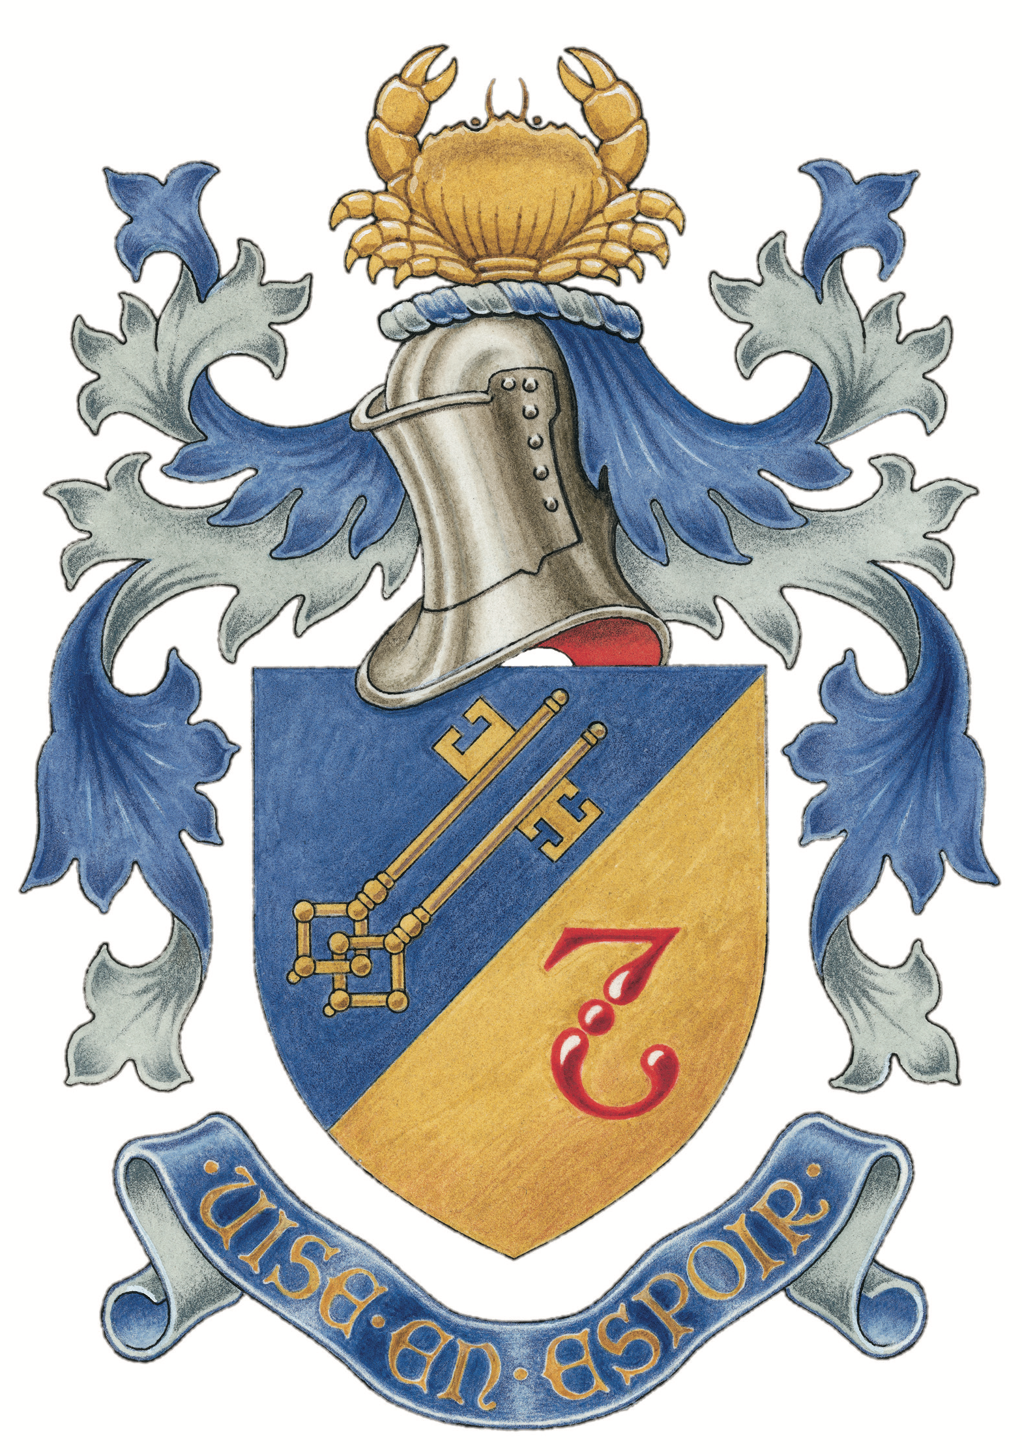

**Saturday 28th July 2018 8.30am – 4.30pm**

**Room B128 Medical School, Queen’s Medical Centre, Derby Road, NG7 2UH**

**LIMTED SPACES!** To book a place email surgicalskillsnuh@gmail.com with your name + grade/year